

PRM/MPsych  
Coursework cover sheet for 2018

**In submitting this work I confirm that I have read and understood the University of Plymouth regulations relating to Assessment Offences, and that I am aware of the possible penalties for any breach of these regulations. I confirm that this is my own independent work.**

Top of Form

Student ID number: 10524332

Module Code: PSY572

Assignment name: Project.

Use of translation software: failure to declare that translation software or a similar writing aid has been used will be treated as an assessment offence. If you have used translation software, please describe it here:

**Markers: DO NOT add grades to annotated scripts**

**Feedback sheet**

Markers: DO NOT add grades to annotated scripts

Students: please leave this page unchanged.

General comments:

Areas for improvement:

**Please also check the script for further comments and annotations**

**Notes for your marker**

**This section is designed to make the feedback you receive more targeted. It is important this is completed before you submit your work.**

What aspects of this work do you most need feedback on?

This might be a particular concept or topic you struggled with, or your structure and writing style.

How have you reflected on previous feedback to change the work you have submitted here?

For example, if previous feedback identified lack of supporting evidence for your argument, explain how you have addressed this here. Give concrete examples (and name which assignment) the feedback you are referring to was from.

Start your own work here…

REMEMBER TO USE A SENSIBLE FILENAME INCLUDING YOUR SRN NUMBER

Some tips on formatting:

* **Don’t change the default margins in this document.** If you do you will annoy markers who use the wider margins to annotate your coursework.
* Use a 12 point font.
* Use double spacing (except for tables)
* Use APA format as the default (except when instructed otherwise). Remember, APA specifies formats for tables, figures and gives guidance on writing style; it’s not solely concerned with reference formats.

Checklist before submitting work:

* Check again — have you answered ***the question that was set***?
* For essays, does each sentence help to strengthen your argument?
* Have you provided evidence for each part of your argument?
* Have you given concrete examples to support your points?
* Have you proofread your work? Always use the spellchecker and (with caution) the grammar checker in your word processor. Even better, leave your draft for a day and read it with fresh eyes.

**Before submitting to the DLE, convert your file to a PDF and check it has been converted correctly.**

REMEMBER TO USE A SENSIBLE FILENAME INCLUDING YOUR SRN NUMBER

Contents

|  |  |
| --- | --- |
| Title page | 7 |
| Statement of ethical compliance. | 8 |
| Abstract. | 9 |
| Introduction. | 10 |
| Method. | 17 |
| Analysis:   * Reaction time analysis and results. * Error rate analysis and results. * Individual analysis and results. * Observations/Questions results. | 21  23  25  27  30 |
| Discussion. | 34 |
| References. | 40 |
| Appendix. | 50 |
|  |  |
|  |  |

Contextual validity: An investigation into the effects of the introduction of everyday environmental characteristics of daily life on neuropsychological testing.

Thesis submitted to the University of Plymouth School of Psychology for the MSc in Psychological Research Methods by David Bennett.

22nd August 2019.

Statement of ethical compliance.

The work reported in this thesis received ethical approval from the Faculty of Health and Human Sciences and complies with the guidelines set by the British Psychological Society.

I would like to acknowledge the following people for their support, knowledge and skills: Dr Chris Longmore, Dr Alyson Norman, Mark Cooper.

And I would like to thank Katie and Chloe for being the eye of the storm during the whole process.

All data and code for this study is available at <https://github.com/davidscottbennett/HSCT-final-data-and-code> or at

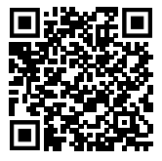

Abstract.

Acquired brain injury often leaves individuals with impairment of executive function that is subtle and highly nuanced. These impairments can reduce the individual’s ability to perform daily activities but can go unidentified with neuropsychological testing within the clinical environment due to an absence of real-life characteristics. The lack of real-life characteristics within the testing environment has resulted in individuals with mild ABI having their functioning overestimated by clinicians. The current study administered the Hayling Sentence Completion Task to individuals with mild ABI in environments with, and without, characteristics of everyday life. This was achieved using an immersive 360° video in a virtual reality headset. The error rate and time to sentence completion was recorded and analysed using an ANOVA. The time to sentence completion demonstrated no significant change in different environments while the error rate increased significantly when individuals with mild ABI were placed in VR. Additional individual analysis was carried out to observe variance of results between participants. The introduction of real-life characteristics did change the results of the test administered, thus, demonstrating the need for an increased sensitivity in neuropsychological testing to account for the subtleties of executive function impairment.

Keywords. Neuropsychological testing, mild ABI, ecological validity.

Introduction

Acquired brain injury (ABI) can have a significant impact on the life of an individual, with neuro-psychiatric sequalae being the prominent cause of disability (Fleminger & Ponsford, 2005). These impairments are often grounded in multiple parts of executive function (EF). What constitutes EF is a highly debated topic; abstract thinking, temporal sequencing, perseveration, insight, planning, self-monitoring, decision making, and behavioural self-regulation are all agreed on as being central to the term ‘executive function’ (McGuire et al., 2014; Wood & Worthington, 2017). Despite on-going debate over the constituents of EF, what is agreed is that EF works synchronously within a system to accomplish goals and that impairment can significantly influence the individual’s ability to perform daily activities in everyday living (Jurando & Rosselli, 2007; [Chan, Shum, Toulopoulou, & Chen, 2008](https://search-proquest-com.plymouth.idm.oclc.org/docview/1673080105?OpenUrlRefId=info:xri/sid:primo&accountid=14711#REF_c13); Fortin, Godbout, & Braun, 2003). The presentation of these impairments is often subtle and hidden which can lead to the individual not being immediately identified as impaired by themselves or by the people and systems that they interact with (House of Lords select committee, 2015).

Whilst ABI related cognitive impairment is acknowledged as being somewhat heterogeneous in nature, executive dysfunction is noted as being a common experience amongst individuals across severities of ABI; from mild to very severe (Dimoska-DiMarco, McDonald, Kelly, Tate, and Johnstone, 2011). The body of literature related to ABI and EF has primarily focused on individuals who have demonstrated moderate to very severe brain injuries (Knight, Titov, & Crawford, 2006; Whyte, Schuster, Polansky, Adams, & Coslett, 2000). The focus of research on the more severe end of the ABI spectrum has attracted criticism for ignoring a large population of people with mild ABI who are, arguably, more likely to pass neurological assessment, thus, go under the rehabilitation radar (Denmark, Fish, Jansari, Tailor, Ashkan, & Morris, 2017). Likewise, the literature concerning impairment in the mild ABI population often neglects neuropsychological outcomes longer than 12 months post-injury. Moreover, the literature that does exist tends to agree on a dissipation of impairment after an initial small interruption in neuropsychological functioning (Rohling, Binder, Demakis, Larrabee, Ploetz, & Langhinrichsen-Rohling, 2011; Carrol et al., 2004). One explanation for these findings is that the tests used to establish the level of cognitive impairment are not adequately sensitive enough to the executive dysfunctions that are often found in mild ABI. Vanderploeg, Curtiss, and Belanger (2005) found that a more sensitive neuropsychological test, the Paced Auditory Serial Addition Test (PASSAT) indicated a perseverance of attentional deficit in participants who had been diagnosed with a mild ABI, 8 years post-injury. Vanderploeg *et al.*’s findings on the longitudinal stability of impairment has been corroborated by other studies, all of which suggest an ongoing impairment in individuals with mild ABI as well as those with moderate or severe (Theadom, Jones, Starkey, McDonald, Barker-Celloo, & Feigin, 2018; Denmark *et al*., 2017; Jansari, Delvin, Agnew, Akesson, Murphy, & Leadbetter, 2014; Ponsford et al., 2014).

Another explanation for these findings is that there is a lack of the essential characteristics of everyday life within the tests being administered, thus, giving an over-estimation of functional ability. This lack of everyday-ness; ambient noise, unpredicted distraction, environmental changes, has led to a subset of individuals with ABI passing neurological tests whilst still exhibiting difficulties in day-to-day living (Jansari *et al*.,2014; Rizzo, Schultheis, Kerns, & Mateer, 2004; Levine, Dawson, Boutet, Schwartz, & Stuss, 2000; Clune-Ryberg et al., 2006; Levine, Dawson, Boutet, Schwartz, & Stuss, 2000; Reid-Ardnt, Nehl, & Hinkebein, 2007).

The most commonly reported impairment amongst individuals with moderate to severe ABI are deficits to divided attention and a vulnerability to external distractors (pro-active interference), thus, disrupting the ability to maintain focus on a task or goal (Whyte, Schuster, Polansky, Adams, & Coslett, 1998). Whyte et al. (1998) found that there was no relationship between impairment and injury severity in regard to this impairment. Pare, Rabin, Fogel, and Pepin (2009) and Wood & Worthington (2017) furthered these findings to individuals with mild ABI with similar results. Likewise, Draper and Ponsford (2008) demonstrated impairment in divided attention and a vulnerability to pro-active interference in individuals with a mild ABI 10 years post-trauma with this impairment showing a greater prevalence compared to other executive dysfunctions. A possibility for this finding may be that inhibiting pro-active interference is found to be unrelated to intelligence whereas other executive functions have demonstrated a moderate relation to intelligence (Miyake, Friedman, Emerson, Witzki, & Howerter, 2000).

Norman and Shallice (1986) offer an explanation of the impairment of divided attention and inhibition in their model of Supervisory Attention System damage. Norman and Shallice suggest a distinction between routine (automatic) and non-routine (controlled) strands of attention. Routine attention does not provide a process in which the individual engages in planning, decision making, correction of errors, novel sequencing of actions, and habitual response inhibition. Conversely, a non-routine process necessitates the individual to supervise their attention to ensuring that the goal of the action is reached (Shallice, 2002). Driving a car is a good example of the interaction of these two systems. The driver will seldom attend to the act of driving unless a novel situation is encountered; a pedestrian stepping out into the road, a detour, roadworks. The introduction of a non-routine action makes the individual supervise their attention to incorporate the novel stimulus into their actions. Norman and Shallice (1986) believe that damage to the supervisory attention system (SAS) is central to executive dysfunction demonstrated in most cognitive impairments presented by ABI.

This effect is higher when the task is repetitive or long in duration, thus, making the task vulnerable to other pro-active interference which may be triggered by external or internal events (Stuss, Shallice, Alexander, & Picton, 1995; Manly, Robertson, Galloway, & Hawkins, 1998). Damage to the SAS impairs the ability to switch attention to the novel stimulus, consider the relevance of the stimulus in relation to the current goal, and either inhibit attention from the stimulus or allow attention to fall onto the stimulus.

Whilst impairment of the SAS may present an explanation of error it does not explain the response time delay observed post-ABI (Madigan, DeLuca,Diamond, Tramontano, & Averil, 2000; Cicerone, 2009). Ozen and Fernandes (2012) suggest that a cognitive slowdown is used as a strategy to delay the identification of stimuli in order to maintain accuracy on cognitively demanding tasks. This strategy is believed to be widespread amongst those who acquired mild brain injuries and retained high cognitive functioning. Data from their study presented a slower response rate from the ABI population when compared to the control whilst the accuracy rate remained the same between groups. These findings were the same over high and low cognitive load conditions with the response time increasing incrementally with cognitive load. These findings may elucidate a reason for the previously held belief about impairment dissipating after an initial period of impaired neuropsychological functioning (Rohling et al, 2011; Carrol et al, 2004) as individuals use a ‘slow down’ strategy to improve error rates in tasks.

The present study proposes that the introduction of real life characteristic on the environment in which a neuropsychological test is administered will have an impact on the results given by individuals with a mild ABI. Participants will be tested within an environment without the characteristics of everyday life; ambient noise, unpredicted distraction, and environmental changes, and within an environment which introduces these characteristics to observe both error rate and response time of high functioning individuals with mild ABI compared to a neurotypical control. The characteristics of everyday life will be achieved using a 360° degree film played through a virtual reality (VR) headset and participants will be tested with the Hayling Sentence Completion Task. Using VR offers a real time, low cost, safe environment which offers replication for data collection (Jansari et al, 2017). The use of VR is emerging as a tool within the clinical psychology tool kit to obtain valid data about client functioning in a real-world environment (Parsons & Phillips, 2017; Rizzo & Shiling, 2018; Campbell, Zakzanis, Jovanovski, Joordens, Mraz, & Graham, 2009).

This study used the Hayling Sentence Completion Task (HSCT) which forms part of the Hayling and Brixton neuropsychological test battery (Burgess and Shallice, 1997) which tests speed of initiation and response suppression. The HSCT was chosen as it relies on verbal responses instead of ‘pen and paper’ paradigm. This makes the HSCT translate to the VR environment within both the time and financial constraints of the study. The HSCT demonstrates a respectable internal consistency (.72-.93), test-retest validity (.78), and a positive correlational relationship with other tests of executive function such as the Dysexecutive Questionnaire (DEX), Community Integration Questionnaire (CIQ), and the Iowa Collateral Head Injury Questionnaire (ICHIQ) indicating sensitivity as a measurement of executive dysfunction (Odhuba, van den Broek, and Johns, 2011). The HSCT comprises of two separate conditions, one where the participant completes a sentence with a logical answer: for example, Q -‘The captain went down with the sinking….’ A – “ship/boat’. In the second task the participant completes the sentence with a non-logical response: for example, Q- ‘the captain went down with the sinking…’ A-‘ Moon”. Each condition is made up of fifteen sentences and is rated on two scales; pass or fail, and time taken to respond. Each condition will be completed outside of the VR environment and inside the VR environment.

We propose two possible outcomes from this study, one being that participants from the ABI group will display a similar time to sentence completion to the non-ABI group in the non-inhibitory trials of the HSCT with only a small increase in response time once in VR. Once the participants are placed in inhibitory condition we expect that the ABI group will take significantly longer to sentence completion to allow for strategy implementation. The time to sentence completion will increase further in the VR environment due to the increased cognitive load. The error rate will remain consistent between groups. If this is the outcome of the testing then it will lend support to the idea of EF impairment being hidden through strategy use.

An alternative outcome from this study will be that the time to sentence completion will remain consistent between groups but error rate will increase as cognitive load increases. If this outcome is observed then one could conclude that participants with a mild ABI did not initiate strategy use to overcome cognitive demand.

Method

*Participants.*

Twenty-six participants were recruited from the participant allocation system at the University of Plymouth for either course credit or one monetary payment to a standard participation credit value or through personal contact with the research cohort. These participants formed two groups; ABI, Participants who had an acquired brain injury (n=9, male = 3, female = 6) and non-ABI, a control group of neurotypical participants (n=19, male = 8, female =11). The ABI group participants all had acquired brain injuries but demonstrated limited observable neuropsychological sequalae and lived independently and had unsupported access to occupational activity.

The acquired brain injury group were defined as individuals who have required hospital admission for the following; a brain tumor, a stroke (ischemic stroke and haemorrhagic stroke), a brain haemorrhage, a brain aneurism, encephalitis, hydrocephalis, concussion, experienced post-traumatic amnesia, hypoxic or anoxic brain injury, or have brain damage due to carbon monoxide poisoning. Participants recruited for the study via the participant allocation system were filtered into the ABI and Non-ABI groups during the enrollment phase of the study. This filtering was done through self-report. At the instruction phase of the study the researcher asked the ABI group participants the nature of their ABI and the duration of time since acquisition. The neurotypical group, according to self-report, had never sustained any kind of injury to the head. At the instruction phase of the study the researcher asked the Non-ABI participants to confirm that they had never acquired a brain injury, experienced an insult to the head, or head medical assessment for brain related injuries or illnesses.

All participants were fluent English speakers and if English was not their first language it had been learned before 5 years of age for inclusion in the study. Participants were also required to have normal or corrected to normal hearing and normal or corrected to normal vision. All procedures were performed in compliance with the University of Plymouth’s ethics laws and guidelines and were approved by the University of Plymouth’s Psychology department.

*Materials*.

The Hayling Sentence Completion Task from the Shallice and Burgess Hayling and Brixton Test Battery (1997) was adapted for use in our study. The test was a web-based program designed using ASPX/HTML5. The test was composed of two conditions, a non-inhibited response and an inhibited response, to sentences with the last word missing. All audio was recorded using TapMedia Voice Recorder on an IPhone SE. Playback of sentences was via the web-based program.

Both conditions were delivered within an immersive environment and outside the immersive environment. All images and associated ambient sounds used within the immersive environment were filmed using a Viewz 360° video camera and viewed using GoPro VR 3.0.5. All images were viewed on a HTC Vive VR system (resolution = 1080 x 1200 pixel per eye, field of view = 110 degrees, refresh rate = 90 Hz). Ambient sounds from the immersive environment were played back through Windows 10 media played at a low volume on Behringer HPM1000 enclosed headphones.

|  |  |
| --- | --- |
|  |  |

*Figure 1:* Images from the 360° film presented to participants in the VR environment.

The research observer was able to observe the immersive environment that the participant was experiencing via a Lenovo ‘Thinkcentre’ monitor and hear the audio input that the participant was experiencing on a pair of Behringer HPM1000 enclosed headphones.

*Procedure.*

Each participant began the experiment by reading and signing the study consent form. They were then informed of the task being a neuropsychological test and what it was testing. This information was also given to them in the online registration form. Due to the Hayling Sentence Completion test being a neuropsychological test which is administered transparently to participants within a clinical setting it was decided that the test should not be an embedded task as to replicate the original test.

Each section of the Hayling Sentence Completion Task used in this study consisted of 2 practice trials followed by 15 randomised trials. These sections were completed sequentially; non-inhibitory and inhibitory. Participants sat at a comfortable distance from the computer screen and put on headphones. The participant then heard the instructions for the test prior to two practice trials, which they then completed. All instruction for the test were used verbatim from the Hayling Sentence Completion Task (1997). The only addition to the content of the original task was to inform the participant of the use of the mouse to initiate and complete the trial.

In the non-inhibitory trials, the participant replied with a word that was congruent with the content of the sentence, “the dog chased our cat up the... (participant then answers).. e.g. tree” for instance. In the inhibitory condition the participant replied with a word that was incongruent with the content of the sentence, ‘the dog chased our cat up the....(participant then answers)… e.g. happy”. During the practice phase the computer screen displayed an audio player that the participant had control over allowing for the instructions to be heard multiple times if the participant wished. Each trial consisted of a sentence being read which had the final word missing. The participant then said the missing word out loud and upon completion pressed the mouse button. The participant then pressed the mouse button again to start the next trial. The time between the initiating press of the mouse button and the finishing press of the mouse button (time A), for each trial, was record. To extract the ‘time to sentence completion’ (time C) the time of the audio stimulus (time B) was subtracted; A – B = C.

During the study phase the computer screen remained blank and participant had no control over audio play back beyond starting the trial and finishing the trial.

Once the participant had completed both the non-inhibitory and inhibitory phases of the study they then re-took the trials within an immersive environment. The stimuli within the immersive environment was a 360° film, including ambient noise, of a busy corridor and was started at the same point for each participant. The order of condition and instructions remained as in the non-immersive environment.

Throughout the experiment an observer heard the same audio input as participants and marked words completing the sentences as correct or incorrect. The observer was also able to follow the direction of the participants available field of vision within the VR headset on a screen that was hidden from the participant. The observer noted any behaviours that pertained to the outcome of the test; patterns of words used, link between the participant field of vision and word used etc.

At the end of the trials the observer asked participants the following questions;

1. How did you find that?
2. Did you find it more difficult in VR?
3. Did you introduce any strategies to aid your performance?

The answers to the questions were noted by the researcher in front of the participant. Participants were given the opportunity to discuss their results and the study further after they had answered the questions.

**Analysis and Results.**

The data from this study was analysed by group and by individual participant analysis within the ABI group (Appendix 1). To compliment the statistical analysis additional analysis was undertaken to give the researcher an insight into the experience of the participant while undertaking the study.

*Omitted data.*

Data points under 400m/s were tagged as outliers and omitted from the final data set to accommodate age and sex difference across groups (Der & Deary, 2006). There were only several data points that fell outside of this timeframe. One data set was removed from the non-ABI group data due to incomplete data.

*Group Analysis and results.*

The data from this study was analysed using two repeated-measures analysis of variance (ANOVAs) with “Environment” as the within subject variable (Non- immersive and immersive) and “Group” as the between subject variable (ABI and non-ABI). This method was used to examine the time taken to complete the sentence between groups and within conditions and accuracy of response between groups and within conditions on the Hayling Sentence Completion Task. An independent two sample t test was run to observe if there was a significant difference between the means on the two groups in each environment on both error rate and the time taken for sentence completion for each group on the Hayling Sentence Completion Task. This t test was also used to extract the effect size (Cohens *d*) of each interaction.

*Reaction time analysis.*

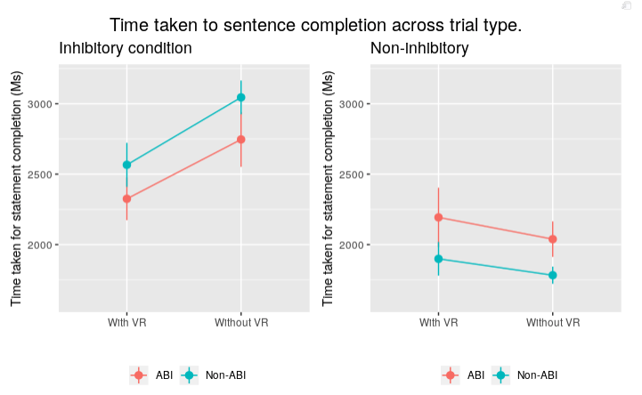

*Figure 2.* Interaction of environment and type of trial (inhibitory and non-inhibitory) on the time taken to sentence completion (m/s) in ABI and non-ABI groups. Error bars are the standard error of the median value.

A mean percentage score, median, and standard deviation were calculated for each group based on the time that it took the participant to respond with the appropriate word at the end of each trial (See Appendix 2). These calculations were made for each environment: VR and non-VR, and within each condition: inhibitory response and non-inhibitory response.

The time taken to complete sentences was entered into a repeated-measures analysis of variance (ANOVA) with Environment (with VR or without VR, within subjects) and Group (ABI or non-ABI, between subjects) as the independent variables and the Time Taken as the dependent variable. The data from the ABI group was not expected to fulfill the criteria for either normality or sphericity so these tests were not applied to the data. However, Norton (1952, as cited in Longmore, Liu, & Young, 2008) found that in departures of normality ANOVA has been found to be a robust method of data analysis.

In line with the hypothesis participants with an ABI did take longer to complete the statement than participants without ABI, surprisingly, both groups completed the statements quicker within the VR environment than the non-VR environment. However, using an ANOVA showed that these findings did not demonstrate a statistical significance F(2,38)=1.486, p = .23. Likewise, there were negligible effect sizes in all interactions within the reaction time analyses. Bayesian analysis offers strong support for the rejection of this hypothesis.

*Error rate analysis*

**

*Figure 3.* Interaction of environment and type of trial (inhibitory and non-inhibitory) on the time error rate in ABI and non-ABI groups. Error bars are the standard error of the mean value.

A mean percentage score and standard deviation for error rate (See Appendix 3) was calculated for each group based on the number of errors that participants made responding with the appropriate word at the end of each trial. These calculations were made for each environment: VR and non-VR, and within each condition: inhibitory response and non-inhibitory response.

The error rate was entered into a repeated-measures analysis of variance (ANOVA) with Environment (with VR or without VR, within subjects) and Group (ABI or non-ABI, between subjects) as the independent variables and the error rate as the dependent variable. Again, tests for sphericity and normality were not carried out.

As hypothesised, participants within the ABI group made a greater number of errors than participants in the non-ABI group within the VR environment F(2,38)=15.56, p = .000. Bayesian analysis offers strong support in favour of this hypothesis.

To check the statistical power of the interaction of the VR environment and ABI on error rate a post hoc power analysis was conducted using G*Power 3.1.9.2 with a total sample size set to 9, effect size = 0.393, β/α ratio= 1, α=.05 (Appendix 4). The current sample size gave a statistical power of .62. When a predictive plot was generated it indicated that to achieve statistical power of .8 a sample of 20 participants would be required which would increase to .9 with 30 participants.

There were negligible differences between group means and effect sizes throughout all of the interactions within the error rate analysis apart from the inhibitory trials within VR for the ABI group, *t*(214)=3.39, p = .000, d = .43.

*Individual Analysis and results.*

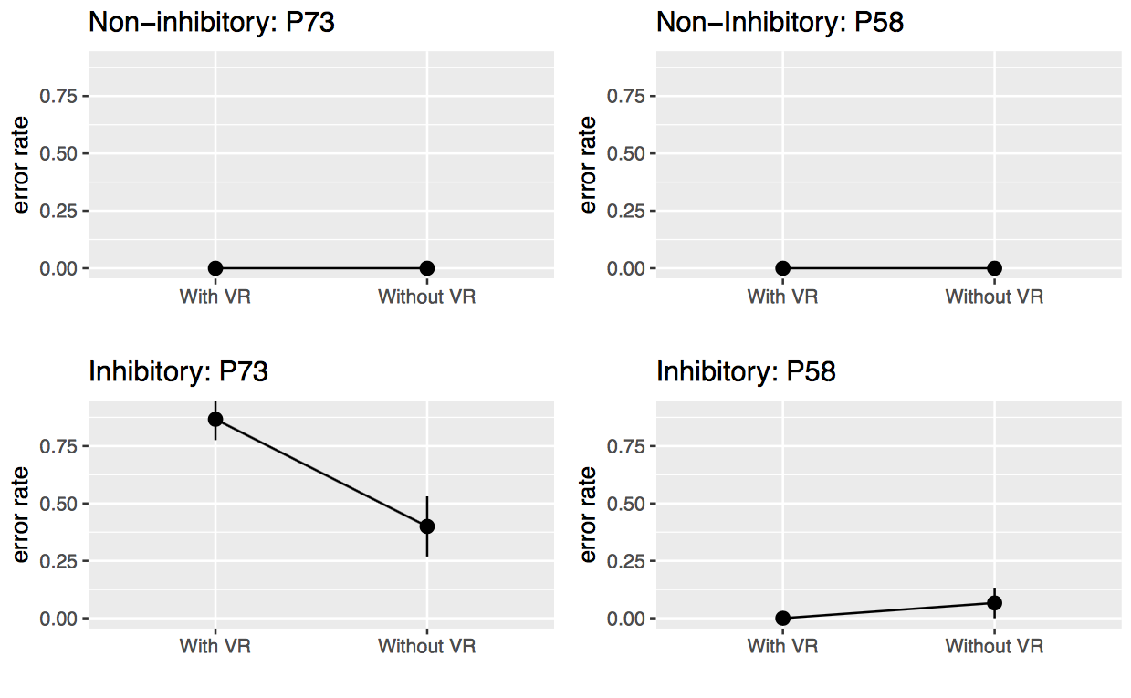

*Figure 4.* The variance in time taken to sentence completion between the participants within the ABI group who demonstrated the smallest (P58) and greatest (P73) error rate.

**

*Figure 5.* The variance in error rate between the participants within the ABI group who demonstrated the smallest (P58) and greatest (P73) error rate.

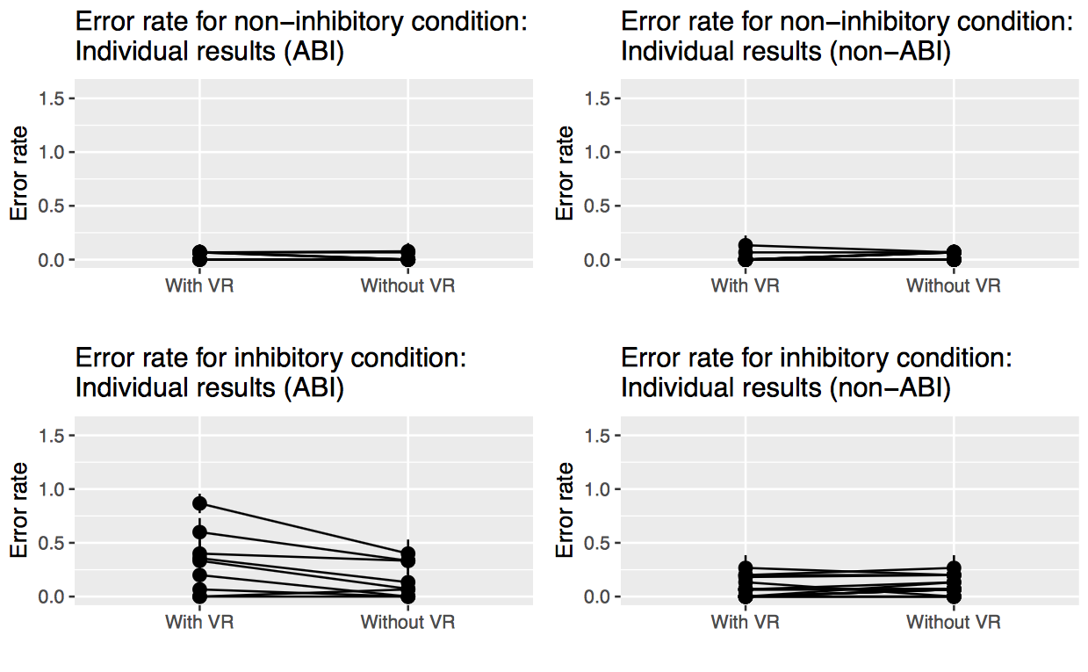

*Figure 6*. Interaction of environment and type of trial (inhibitory and non-inhibitory) on the time error rate for all participants. Error bars are the standard error of the mean value.

Additional analysis was carried out using each individual from the ABI group as a single case study to observe the individual variance for each member of the ABI group in comparison to the normative sample (the non-ABI group). The software packages Revised Standardized Difference Test (RSDT) (Garthwaite & Crawford, 2005) and DiffBayes (Crawford & Garthwaite, 2007) were used for analysis, both of which are available online. Crawford and Garthwaite (2005) demonstrated, through Monte Carlo simulation, a reduced type 1 error rate for small control samples compared to larger control samples using the RSDT. Likewise, RSDT uses the normative group, in this case the non-ABI group, as the parameters by which the clinical sample is measure. This method includes local norms which are more inclined to be similar to the clinical sample, thus, allowing more rigorous analysis of dissociation between impairment and other factors (Crawford & Howell, 1997). Due to the sample size of this study being recognized as small within the domain of neuropsychology (Crawford & Howell, 1998) the use of software developed for single case against normative sample was used.

Analysis of the between group data did not demonstrate the variance of results within the ABI group. The number of errors made by participants, and the mean, median, and standard deviation for time taken to sentence completion was calculated for each member of the ABI group (See appendix 1). The error rate of each participant was compared to the error rate of the control using the Revised Standardised Difference Test and DiffBayes (See appendix 1). The output of these tests showed substantial differences between group members in error rate (Figures 2 & 3).

When compared to the control a majority of the ABI group exhibited zero percent chance of fitting within the non-ABI group parameters. This result was found in both the general scores of the test and the direction of the data submitted. Participant 48 was the only individual whose results did not show a statistical significance in the RSDT; t = (17)1.989, p=.06., and demonstrated a probability of 48.31% of the control group demonstrating the same results in the same direction using BayesDiff.

*Observation and Question analysis and results.*

*Observations*

The observations taken within this study were noted in an informal manner as they were being used as an observation of shared group behaviours and not concentrating on the individuals. Additionally, the observations were being used to cross reference the content of the answers given to the questions. This gave the researcher an opportunity to gain an understanding into the experience of the participant within the VR environment and observe any behaviours that may have indicated the implementation of strategies to aid successful trial completion. All comments made from the questions asked were noted. The analysis from the observations and the questions was brief and were being used to give an understanding of the difference in experience of the neuropsychological test being used between groups. There will be no secondary analysis as this data was complimentary to the quantitative data collected and not intended to be a qualitative or observational study separate from the quantitative data presented.

During the non-VR condition and the non-inhibitory trials in the VR non-participants demonstrated any observable actions that would have had an impact on the outcome of the results in the trial. Participants were given a short period of time to get used to being immersed with in the VR environment, during this time people looked around the environment but once the non-inhibitory trial in VR commenced non-ABI participants tended to look forward and not investigate further while ABI participants tended to follow the distractions around as much as their physical movement would allow. Within the inhibitory VR environment non-ABI participants clustered into two identifiable groups; one which used the environment within the VR environment to supply the statement word, and one which did not move their view and recalled lists to supply the statement words (Appendix 5).

*Questions*

1. *How did you find that?*

After completing the trials participants from both groups commented that they did find the VR environment made the trials harder. Each group stated that ‘distraction’ made concentrating more difficult. One of the ABI group participants said it would have been impossible if it had been within two years of their accident which indicates that the severity of his impairments had diminished. However, there was still an above average error rate in his data when compared to the group mean. One participant from the ABI group said that they felt having three children had given them the ability to ignore distractions.

1. *Did you find it more difficult in VR?*

Within the non-ABI group, several participants found the environment challenging as it was one that they knew so the distractors within it were more salient; it may have been people that they knew. The members of the non-ABI group did not comment on this. This could elucidate one of the reasons for more errors within VR from the ABI group; the non-ABI group were aware of the distractors but did not invest the cognitive load to investigate the distractor as their SAS inhibited that action. This was highlighted when one participant in the ABI group commented that he was aware that he gave an incorrect answer due to a friend walking past the camera. Despite being aware that he was performing poorly due to his cognitive investment in the distractors he still did not inhibit his behaviours.

Within the ABI group one participant stated that they did not find it hard in the VR environment. However, their performance within the VR environment demonstrated a considerable increase in incorrect answers and when compared to the ABI cohort they demonstrated one of the most impaired performance.

Those who demonstrated a considerable disparity between their test scores oftenfelt that their performance in the inhibit trials would have been similar within and outside of VR. They demonstrated an understanding of errors in both conditions but appeared to be unaware of the increase quantity of errors. Interestingly, ABI participants did not request information regarding theirs score on each trial whereas in the non-ABI group this interest was evident in over half of the cohort. However, having the knowledge that they had made errors may have been enough, to be made more aware of their impairment may have been psychologically difficult to address.

1. *Did you introduce any strategies to aid your performance?*

When asked if they had used a strategy to aid their performance seven participants from the non-ABI group said that they used environmental cues to complete the inhibitory condition sentences, one repeated a group of words, and three repeated categorical lists. One participant stated that they tried to use a rule whereby the logical word would be replaced by a noun if it was a verb or vice versa. However, this strategy was found to be too difficult to operationalise so they reverted to using verbal cues. No participants within the ABI group said that they had employed a strategy when in the VR inhibitory condition. One participant from the ABI group did say that towards the end of the inhibitory VR environment trial she closed her eyes “*halfway through*” as it “*had become too much for me*”. This could be considered as the implementation of a strategy, albeit, one which was actioned during the task and, arguably, as a defensive rather than a proactive strategy.

**Discussion**

The findings of this study demonstrate that individuals who have sustained a mild ABI perform worse on the HSCT than their Non-ABI control. In itself this finding is not unexpected, the HSCT is designed to establish neurological impairment of response inhibition in individuals who are suspected of neuropsychological differences. However, what the current study did establish is that individuals with a mild ABI who registered no difference from a neuro-typical control population in the HSCT when administered in a setting devoid of everyday distractors, a clinical office setting for example, performed significantly worse than the control when the test was administered in a setting with the characteristics of everyday life. The current study examined two factors that were hypothesized to show significant differences between the ABI and non-ABI groups when tested with the HSCT inside and outside of a VR environment. The time to sentence completion and error rate of each participant was measured and analysed.

The time taken to sentence completion was greater in the ABI group but only to a value of circa 300 m/s. These findings were consistent over all trials; inhibitory and non-inhibitory, with VR and without VR. Both groups were slower in the inhibitory trials compared to the non-inhibitory trials as anticipated in the first hypothesis. This was expected due to the increased cognitive load placed on the participant. However, contrary to the first hypothesis the ABI group performance did not deviate from the pattern of the non-ABI group in the inhibitory trials. These findings indicate that a cognitive slowing may be evident in individuals with mild ABI but the consistent time difference between groups across all trials and conditions points towards the slow down not being attributable to the implementation of an error correction strategy. Additionally, the instability of error rate in the ABI group also lends support to the rejection of the first hypothesis.

Interestingly, both groups exhibited a decrease in the time to sentence completion in the inhibitory condition within the virtual environment compared to the non-virtual environment. One explanation for this could be the order in which participants took the tests; all participants would have already taken an inhibitory and non-inhibitory trial previously so were better prepared to take the trial and it was no longer a non-routine process. This criticism is one that has been ascribed to the measurement of executive function previously (Salthouse, Atkinson, & Berish, 2003). However, the second trial in the non-inhibitory condition did not demonstrate the same pattern with participants taking longer within VR to complete the trial which suggests that habituation is not responsible for this increase. Further research into possible explanations for this time decrease would be encouraged in the future.

The error rate was where the differences between groups became apparent. Specifically, during the inhibitory trials within the VR environment. Within the non-inhibitory trials both groups performed similarly with each group making a small number of errors. The error rate in the inhibitory trials, when outside of VR, was also similar with no significant difference between groups. However, once ABI group participants were immersed in the VR environment for the inhibitory trials the error rate increased significantly while the non-ABI group error rate remained consistent between VR and non-VR environments.

This finding supports the second hypothesis which predicted a sudden increase in error rate with the introduction of the VR environment in the ABI group. Furthermore, these findings are consistent with the Norman and Shallice (1986) SAS model. As the number of stimuli increased the attentional system was unable to supervise attention to the non-routine action (the need to answer with a non-logical answer in the inhibitory condition) and continued to respond with the routine action (the logical conclusion to the sentence) even though this action would not achieve the required goal.

The additional cognitive load on the attentional system was recognized by participants of both groups within the study. When questioned on the difficulty of the inhibitory trials in VR participants stated that there was a sense of increasing difficulty when participants were required to inhibit the routine response in favour of the novel response. Several of the ABI group stated that they found the difficulty overwhelming.

However, the behaviours observed, and the answers given to the questions posed by the researcher, revealed an absence of declared strategy implementation compared to the non-ABI group. The absence of a conscious strategy to ameliorate the possibility of error raises further questions over the ‘cognitive slowdown as strategy’ model. One could argue that the size of the delay, circa 300 m/s, would be too short to action a strategy as it is under the 400 m/s as suggested by Der & Deary (2006).

The increase in error rate during the inhibitory trials in the VR environment for the ABI group demonstrates that the characteristics of everyday life, characteristics that were absent in the initial administration of the HSCT, had an impact on participants’ ability to moderate their responses. These findings highlight a need for an increased sensitivity in the administration of neurological testing to give a more realistic measurement of functional cognitive impairment. Findings from this study indicate the efficacy of VR as a tool for increasing the sensitivity of the HSCT. Furthermore, VR was able to offer benefits for both participant and researcher. For the participant it offered a safe environment that was accessible despite physical impairment. For the researcher the environment was replicable, and available at a relatively low cost. Additionally, the data presented reveals an additional level of sensitivity that can be used to isolate and determine the level of impairment that would otherwise have been undiagnosed, in the case of this study those with mild ABI. This is in agreement with findings by Parsons and Phillips (2017), Rizzo and Shiling (2018), Campbell et al. (2009), and Jansari et al (2017) who posit that the use of virtual reality within psychological testing does offer a realism that gives a truer understanding of the functional ability of the person being tested, especially if the impairment is highly nuanced as often observed in mild ABI as stated by Pare, Rabin, Fogel, and Pepin (2009), Wood and Worthington (2017), Draper and Ponsford (2008) and Venderploeg et al. (2007). The data collected for this study all came from individuals who has received mild ABI but, in line with the findings of Vanderploeg et al (2007) and Draper and Ponsford (2008), still demonstrated impairment that would have an impact on their day to day lives ( Jurando & Rosselli, 2007; [Chan, Shum, Toulopoulou, & Chen, 2008](https://search-proquest-com.plymouth.idm.oclc.org/docview/1673080105?OpenUrlRefId=info:xri/sid:primo&accountid=14711#REF_c13); Fortin, Godbout, & Braun, 2003).

As pointed out by The House of Lords select committee (2015) the heterogeneity of impairment following ABI makes brain injury a hard injury to quantify. One could argue that this statement is pertinent to the research that surrounds brain injury as well as the assessment of impairment in the clinic. Using group data alone in this study would have led to assumptions being made about the overall level of impairment displayed by individual group members. Whilst the group differences within the time to sentence completion results were limited, within the error rate results the differences within the ABI group were evident (see Figure 4). Examples of these differences can be seen with the comparison between Participant 58, who made zero errors in the inhibitory trials, and Participant 73, who made 6 errors in the inhibitory non-VR condition and 13 errors in the inhibitory VR condition demonstrating the disparity between ABI group participant output (see Figure 3). Should one look at the group analysis then an over estimation of impairment is made on Participant 58 while Participant 73 has an underestimation of impairment. This pattern is observable throughout the ABI group data with no individual participant falling on either the mean or median of the corresponding dataset. Likewise, an overestimation of impairment can happen too. When analysed using RSDT and DiffBayes Participant 48 exhibited a test score that placed them in the centre of the normative population distribution with 48.31% of the control population demonstrating the same results in the same direction. Without individual analysis impairment would have been assumed due to group affiliation. The data presented through individual case analysis emphasizes the heterogeneity of brain injury and the need for clinical and neuropsychological research and assessment to incorporate individual analysis as promoted by Crawford and Howell (1998) and Crawford and Garthwaite (2006) to avoid over-estimations and under-estimations of neuropsychological functioning.

Given the differences demonstrated between the administration of the HSCT in VR and no-VR on the impairment specific trials it would be useful to observe how the results differ across other neuropsychological tests for EF. This may offer the ability to add sensitivity to neuropsychological testing other than the HSCT that may be needed for individuals who acquire mild ABI and go otherwise undiagnosed of impairment. Furthermore, making impairments evident that are too sensitive to be identified through current neurological may increase the rehabilitation potential for individuals who have more subtle neuropsychological impairments to EF. Firstly, from the clinical perspective it would offer a more sensitive tool for evaluation of rehabilitation outcomes, secondly from the personal perspective, it would offer an explanation to individual as to their experiences of limitations in their daily functioning, occupational activity, and day to day living.

# **References.**

Ardila, A. (2018). Is intelligence equivalent to executive functions? *Psicothema*, 30(2), 159-14.

Belleville, S., Rouleau, N, & van der Linden, M. (2006). Use of the Hayling task to measure inhibition to proponent responses in normal aging and Alzheimer’s disease. *Brain and Cognition*, 62, 113-119.

Burgess, P., & Shallice, T. (1997). *The Hayling and Brixton Tests*. Bury St Edmunds, England: Thames Valley Test.

Campbell, Z., Zakanis, K., Jovanovski, D. Joordens, D., Mraz, R., & Graham, S. (2009) Ecological validity of clinical neuropsychology: An fMRI case study elucidating the neural basis of planning by comparing the tower of London task with a three dimension navigational task. *Applied Neuropsychology*, 16(4), 295-306.

Carrol, L., Cassidy, D., Peloso, P., Borg, J., von Holst., H., Holm, L., Paniak, C., & Pepin, M. (2004) Prognosis for mild traumatic brain injury: Results of the WHO collaborating centre task force on mild traumatic brain injury. *Journal of Rehabilitation Medicine*, 43, 84 -105.

Cicerone, K. (2009) Attention deficits and dual task demands after mild traumatic brain injury. *Brain injury*, 10(2), 79-90.

Chan, R., Shum, D., Toulopoulou, T., & Chen, E. (2008). Assessment of executive functions: review of instruments and identification of critical issues. *Archives of Clinical Neuropsychology,* 23(2), 201-216.

Clune-Ryberg, M., Blanco-Campal, A., Carton, S., Pender, N., O’Brien, D., Phillips, J., & Burke, T. (2011). The contribution of retrospective memory, attention and executive functions to the prospective and retrospective components of prospective memory following TBI. *Brain Injury*, *25*(9), 819-831.

Crawford, J. & Garthwaite, P. (2006) Detecting dissociations in single case studies: Type I errors, statistical power and the classical versus strong distinction. *Neuropsychologia*, 44, 2249-2258.

Crawford, J. & Howell, D. (1997) Comparing and individuals test score against norms derived from small samples. *The Clinical Neuropsychologist*, 12(4), 482-486.

Denmark, T., Fish, J., Jansari, A., Tailor, J., Ashkan, K., & Morris, R. (2017). Using virtual reality to investigate multitasking ability in individuals with frontal lobe lesions. *Neuropsychological Rehabilitation*, 1-22.

Der, G. & Deary, I. (2006) Age and sex differences in reaction time in adulthood: Results from the United Kingdom Health and Lifestyle survey. *Psychology and Aging*, 21(1), 62-73.

Dimoska-Di Marco, A., McDonald, S., Kelly, M., Tate, R., & Johnstone, S. (2011). A meta-analysis of response inhibition and Stroop interference control deficits in adults with traumatic brain injury (TBI). *Journal of Clinical and Experimental Neuropsychology*, *33*(4), 471-485.

Draper, K., & Ponsford, J. (2008). Cognitive functioning ten years following traumatic brain injury and rehabilitation. *Neuropsychology*, *22*(5), 618.

Fleminger ,J., & Ponsford, J. (2005). Long terms outcome after traumatic brain injury. *British Medical Journal,* 331, 1419.

Fortin, S., Godbout, L., & Braun, C. (2003) Cognitive structure of executive deficits in frontal lesioned head trauma patients performing activities of daily living. *Cortex*, 39(2), 273-291.

House of Lords select committee on mental capacity act 2005 (2014) *Mental capacity act 2005: post legislative scrutiny.* House of Lords: London.

Jansari, A., Delvin, A. Agnew, R., Akesson, K., Murphy, L., & Leadbetter, T. (2014). Ecological assessment of executive functions: A virtual new paradigm. *Brain Impairment*, 15(2), 71-87.

Johansson, B., Berglund, P, & Ronback, L. (2009) Mental fatigue and impaired information processing after mild and moderate traumatic brain injury. *Brain Injury*, 23, 1027-1040.

Jurando, M. & Rosselli, M. (2007) The elusive nature of executive functions: A review of our current understandings. *Neuropsychology Review*, 17, 213 – 233.

Knight, R. G., Titov, N., & Crawford, M. (2006). The effects of distraction on prospective remembering following traumatic brain injury assessed in a simulated naturalistic environment. *Journal of the International Neuropsychological Society*, *12*(1), 8-16.

Madigan, N., DeLuca, J., Diamond, B., Tramontano, G., & Averil, A. (2000) Speed of information processing in traumatic brain injury: Modality specific factors. *Journal of Head Trauma Rehabilitation*, 15(3), 943-956.

Manly, T., Robertson, I., Galloway, M., & Hawkins, K. The absent mind: Further investigations of sustained attention to response. *Neuropsychologica*, 37, 661-670.

McGuire, B., Morrison, T., Barker, L. Morton, N., McBrinn, J., Caldwell, S., Wilson, C., McCann, J., Carton, S., Delargy, M., & Walsh, J. (2014) Impaired self-awareness after traumatic brain injury: Inter reliability and factor structure of the dysexecutive questionnaire (DEX) in patients, significant others and clinicians. *Frontiers in Behavioural Neuroscience*, 8, 1-7.

Miyake, A., Friedman, N., Emerson, M., Witzki, A, & Howerter, A. 2000). The unity and diversity of the executive functions and their contributions to complex “frontal lobe” tasks. *Cognitive Psychology*, 41, 49-100.

Norman, D., & Shallice, N. (1980) *Attention to action: Willed and automatic control of behaviour.* University of California, San Diego, Center for Human Information Processing: *CHIP Report* 99, 1980

Norton, D. W. (1952). An empirical investigation of some effects of non-normality and heterogeneity on the F-distribution. *Unpublished doctoral dissertation*, University of Iowa, Iowa City.

Odhuba, R. A., Van Den Broek, M. D., & Johns, L. C. (2005). Ecological validity of measures of executive functioning. *British Journal of Clinical Psychology*, *44*(2), 269-278.

Ozen, L. & Fernandes, M. (2012) Slowing down after a mild traumatic brain injury: A strategy to improve cognitive task performance? *Archives of Clinical Neuroscience*. 27, 85-100.

Pare, N., Rabin, L., Fogel, J, & Pepin, M. (2009) Mild traumatic brain injury and it’s sequalae: Characterisation of divided attention deficits. *Neuropsychological Rehabilitation*, 19(1), 110 – 137.

Parsons, T., & Phillips, A (2017) Virtual reality for psychological assessment in clinical practice. *Practice Innovations*, 1(3), 197-217.

Ponsford, J., Downing, M, Olver, J, Ponsford, M., Acher, R., Carty, M., & Spitz, G. (2014). Longitudinal follow-up of patients with traumatic brain injury: Outcome at two, five, and ten years post-injury. *Journal of Neurotrauma, 31*(1), 64-77.

Reid-Arndt, S., Nehl, C. & Hinkebein, J. (2007) The frontal systems behaviour scale (FrSBe) as a predictor of community integration following traumatic brain injury. *Brain Injury*, 21, 1361-1369.

Rizzo, A. & Shilling, R. (2018) Clinical virtual reality tools to advance the prevention, assessment, and treatment of PTSD. European Journal of Psychotraumatology, 8(5), 1-20.

Rohling, M., Bindr, L., Demakis, G., Larrabee, G., Ploetz, D., & Langhinrichsen-Rohling, J. (2011) A meta-analysis of the neuropsychological outcome after mild traumatic brain injury: Re-analysis and reconsiderations of Binder et al. (1997), Frencham et al. (2005), and Pertab et al. (2009). *The Clinical Neuropsychologist*, 25(4), 608 – 623.

Rizzo, A., Schulteis, M., Kerns, K., & Mateer, C. (2004). Analysis of assets for virtual reality applications in neuropsychology. *Neuropsychological Rehabilitation*, 14(1-2), 207-239.

Shallice, T. (2002) Fractionation of the supervisory system. In Stuss & Knight (Eds.) *Principles of the Frontal Lobe Function* (pp. 261-277) New York, Oxford University Press.

Stuss, D., Stethem, L., Hugenholtz, H., Picton, T., Pivik, J., & Richard, M. (1989) Reaction time after head injury: fatigue, devided attention, and consistency of performance*. Journal of Neurology, Neurosurgery, & Psychiatry*, 52(6), 742-748.

Stuss, D., Shallice, T., Alexander, M., & Picton, T. (1995) A multi-disciplinary approach to anterior attentional functions. *Annuls of the New York Academy of the Sciences*, 769, 191-209.

Sweller, J (1988) Cognitive load during problem solving: Effects on learning. Cognitive Science, 12, 257-285.

Theadom,A., Jones, K. Starkye, N., McDonald, S., Barker-Collo, S., & Feigin, V. (2018) Links between mild traumatic brain injury, cognitive impairment, and social inference four years post-injury. *Archives of Physical Medicine and Rehabilitation*. 99(11), 140.

Vanderploeg, R., Curtiss, G., & Belanger, H. (2005) Long-term neuropsychological outcomes following mild traumatic brain injury. *Journal of the International Neuropsychological Society*, 11, 228-236.

Whyte, J., Schuster, K., Polansky, M., Adams, J., & Coslett, H. (2000). Frequency and duration of inattentive behavior after traumatic brain injury: Effects of distraction, task, and practice. *Journal of the International Neuropsychological Society*, *6*(1), 1-11

Winkens, I., Van Heugten, C., Wade, D., & Fasotti, L. (2009) Training patients in time pressure management: A cognitive strategy for mental slowness. Clinical Rehabilitation, 23, 79-90.

Wood, R. & Worthington, A. (2017) Neurobehavioral abnormalities associated with executive dysfunction after traumatic brain injury. *Frontiers in Behavioural Neuroscience*, 11(195), 1-9.

Wood, R. & Liossi, C. (2006). The ecological validity of executive tests in a severely brain injured sample. *Archives of Clinical Neuropsychology*, *21*(5), 429-437.

Yu, I., Mortensen, J., & Khanna, P. (2012). Virtual Realism enhances realistic response in an immersive virtual environment – part 2. *IEEE Computer Graphics and Applications*, 29(3), 36-4.

**Appendix**

*Appendix 1.*

**Participant information.**

*Tables 1-9: Summary tables for all participants in the ABI group within both the time taken to sentence completion (m/s) and error rate (number of incorrect answers per condition) trials.*

**Participant 58:**

Participant 58 is a Female who received a concussion over 10 years ago. She was unconscious for a short period of time but did not receive medical attention immediately. After 24 hours she attended hospital due to symptoms of concussion. She has completed an undergraduate degree since the concussion and currently works in academic research.

**Time taken to complete sentence.**

|  |  |  |  |  |  |  |  |  |  |  |  |  |  |  |  |  |  |  |  |  |  |  |  |  |  |  |  |  |  |  |
| --- | --- | --- | --- | --- | --- | --- | --- | --- | --- | --- | --- | --- | --- | --- | --- | --- | --- | --- | --- | --- | --- | --- | --- | --- | --- | --- | --- | --- | --- | --- |
| |  |  |  |  |  |  | | --- | --- | --- | --- | --- | --- | | Participant | Environment | Condition | Mean | Median | SD | | 58 | Non - VR | Non-Inhibit | 1684 | 939.5 | 2715 | |  | VR | Non-Inhibit | 1592 | 1427 | 782.4 | |  | Non-VR | Inhibit | 882.4 | 864 | 313.1 | |  | VR | Inhibit | 1666 | 1178 | 1066 | |

**Error rate.**

|  |  |  |  |
| --- | --- | --- | --- |
| Participant | Environment | Condition | Error rate |
| 58 | Non - VR | Non-Inhibit | 0 |
|  | VR | Non-Inhibit | 1 |
|  | Non-VR | Inhibit | 0 |
|  | VR | Inhibit | 0 |

**Revised Standardised Difference Test (RDST) and DiffBayes results.**

|  |  |
| --- | --- |
| Participant | Analysis |
| 58 | RDST | Results from applying RDST: t = 18.765 , df = 17 , p= .000.  Estimated % of control exhibiting more extreme difference: 0.00% |
|  | BayesDiff | % of control population exhibiting a more extreme discrepancy in the same direction:  Bayes point estimate = 0.004 %, Lower 95% = 0.00 %, Upper 95% = 0.389 %. |

**Participant 48:**

Participant 48 is a male in his early 20’s who received a concussion within the last 3 months playing rugby. He was not aware of losing consciousness but was informed by the team physiotherapist that he had. He received medical treatment immediately. Currently studying at degree level.

**Time taken to sentence completion.**

|  |  |  |  |  |  |
| --- | --- | --- | --- | --- | --- |
| Participant | Environment | Condition | Mean | Median | SD |
| 48 | Non - VR | Non-Inhibit | 1173 | 1469 | 1039 |
|  | VR | Non-Inhibit | 2456 | 830 | 2414 |
|  | Non-VR | Inhibit | 849.1 | 778 | 323.7 |
|  | VR | Inhibit | 1304 | 1345 | 323.7 |

**Error rate.**

|  |  |  |  |
| --- | --- | --- | --- |
| Participant | Environment | Condition | Error rate |
| 48 | Non - VR | Non-Inhibit | 1 |
|  | VR | Non-Inhibit | 1 |
|  | Non-VR | Inhibit | 0 |
|  | VR | Inhibit | 0 |

**Revised Standardised Difference Test (RDST) and DiffBayes results.**

|  |  |
| --- | --- |
| Participant | Analysis |
| 48 | RDST | Results from applying RDST: t = 1.989, df = 17, p= 06.  Estimated % of control exhibiting more extreme difference: 3.15% |
|  | BayesDiff | % of control population exhibiting a more extreme discrepancy in the same direction:  Bayes point estimate = 48.31%, Lower 95% = 30.58, Upper 95% = 66.17%. |

**Participant 52:**

Participant 52 is a male in his mid 50’s who fell from height causing a depressed skull fracture resulting in left frontal lobe damage. He lost consciousness at the time of the insult and remained in an induced coma for a short period of time. Currently in part time employment.

**Time taken to sentence completion.**

|  |  |  |  |  |  |
| --- | --- | --- | --- | --- | --- |
| Participant | Environment | Condition | Mean | Median | SD |
| 52 | Non - VR | Non-Inhibit | 2089 | 877 | 3172 |
|  | VR | Non-Inhibit | 3087 | 2316 | 2235 |
|  | Non-VR | Inhibit | 4027 | 3660 | 1613 |
|  | VR | Inhibit | 3615 | 2844 | 2000 |

**Error rate.**

|  |  |  |  |
| --- | --- | --- | --- |
| Participant | Environment | Condition | Error rate |
| 52 | Non - VR | Non-Inhibit | 0 |
|  | VR | Non-Inhibit | 0 |
|  | Non-VR | Inhibit | 5 |
|  | VR | Inhibit | 6 |

**Revised Standardised Difference Test (RDST) and DiffBayes results.**

|  |  |
| --- | --- |
| Participant | Analysis |
| 52 | RDST | Results from applying RDST: t = 53.278, df = 17, p= .000  Estimated % of control exhibiting more extreme difference: 0.00% |
|  | BayesDiff | % of control population exhibiting a more extreme discrepancy in the same direction:  Bayes point estimate = 0.82 %, Lower 95% = 0.00%, Upper 95% = 0.052 %. |

**Participant 53:**

Participant 53 is a female in her early 70’s who had a haemorrhagic stroke two years ago. She demonstrates hemiplegic physical impairment on her right side.

**Time taken to sentence completion.**

|  |  |  |  |  |  |
| --- | --- | --- | --- | --- | --- |
| Participant | Environment | Condition | Mean | Median | SD |
| 53 | Non - VR | Non-Inhibit | 5602 | 5334 | 946.1 |
|  | VR | Non-Inhibit | 5951 | 4939 | 598.5 |
|  | Non-VR | Inhibit | 7149 | 7085 | 1237 |
|  | VR | Inhibit | 8285 | 7850 | 2366 |

**Error rate.**

|  |  |  |  |
| --- | --- | --- | --- |
| Participant | Environment | Condition | Error rate |
| 53 | Non - VR | Non-Inhibit | 0 |
|  | VR | Non-Inhibit | 1 |
|  | Non-VR | Inhibit | 5 |
|  | VR | Inhibit | 8 |

**Revised Standardised Difference Test (RDST) and DiffBayes results.**

|  |  |
| --- | --- |
| Participant | Analysis |
| 53 | RDST | Results from applying RDST: t = 8.95 , df = 17 , p= .000  Estimated % of control exhibiting more extreme difference: 0.00% |
|  | BayesDiff | % of control population exhibiting a more extreme discrepancy in the same direction:  Bayes point estimate = 0.03 %, Lower 95% = 0.00 , Upper 95% = 0.00 %. |

**Participant 55:**

Participant 55 is a female in her mid 20’s who had an abnormal growth removed from her optic nerve 3 years ago. Surgical access to the growth included a craniotomy and incision into the brain. During the surgical procedure participant 55 remained conscious but sedated. She is currently studying at Masters level.

**Time taken to sentence completion.**

|  |  |  |  |  |  |
| --- | --- | --- | --- | --- | --- |
| Participant | Environment | Condition | Mean | Median | SD |
| 55 | Non - VR | Non-Inhibit | 2865 | 2908 | 1476 |
|  | VR | Non-Inhibit | 2850 | 2252 | 2638 |
|  | Non-VR | Inhibit | 2025 | 1771 | 1337 |
|  | VR | Inhibit | 1712 | 1454 | 763.5 |

**Error rate.**

|  |  |  |  |
| --- | --- | --- | --- |
| Participant | Environment | Condition | Error rate |
| 55 | Non - VR | Non-Inhibit | 1 |
|  | VR | Non-Inhibit | 1 |
|  | Non-VR | Inhibit | 0 |
|  | VR | Inhibit | 3 |

**Revised Standardised Difference Test (RDST) and DiffBayes results.**

|  |  |
| --- | --- |
| Participant | Analysis |
| 55 | RDST | Results from applying RDST: t = 9.51 , df = 17 , p= .000  Estimated % of control exhibiting more extreme difference: 0.00% |
|  | BayesDiff | % of control population exhibiting a more extreme discrepancy in the same direction:  Bayes point estimate = 0.00%, Lower 95% = 0.00% , Upper 95% = 0.00%. |

**Participant 56:**

Participant 56 is a female in her mid 20’s who received a concussion over ten years ago. She did lose consciousness and received immediate medical treatment. She is currently studying at undergraduate level.

**Time taken to sentence completion.**

|  |  |  |  |  |  |
| --- | --- | --- | --- | --- | --- |
| Participant | Environment | Condition | Mean | Median | SD |
| 53 | Non - VR | Non-Inhibit | 3060 | 3013 | 486.9 |
|  | VR | Non-Inhibit | 1838 | 1714 | 866.7 |
|  | Non-VR | Inhibit | 2935 | 2596 | 1379 |
|  | VR | Inhibit | 2771 | 2566 | 1017 |

**Error rate.**

|  |  |  |  |
| --- | --- | --- | --- |
| Participant | Environment | Condition | Error rate |
| 56 | Non - VR | Non-Inhibit | 0 |
|  | VR | Non-Inhibit | 1 |
|  | Non-VR | Inhibit | 2 |
|  | VR | Inhibit | 5 |

**Revised Standardised Difference Test (RDST) and DiffBayes results.**

|  |  |
| --- | --- |
| Participant | Analysis |
| 53 | RDST | Results from applying RDST: t = 42.52, df = 17, p= .000  Estimated % of control exhibiting more extreme difference: .000% |
|  | BayesDiff | % of control population exhibiting a more extreme discrepancy in the same direction:  Bayes point estimate = 0.00%, Lower 95% = 0.00% , Upper 95% = 0.00%. |

**Participant 59:**

Participant 59 is a female in her early 20’s who had a brain tumour removed 5 years ago. She did have both physical and cognitive impairment as a result of the tumour and its subsequent removal for which she received clinical rehabilitation. She currently demonstrates minimal physical or cognitive impairment and is currently studying at undergraduate master’s level.

**Time taken to sentence completion.**

|  |  |  |  |  |  |
| --- | --- | --- | --- | --- | --- |
| Participant | Environment | Condition | Mean | Median | SD |
| 59 | Non - VR | Non-Inhibit | 1630 | 1492 | 886.9 |
|  | VR | Non-Inhibit | 1134 | 1084 | 510.2 |
|  | Non-VR | Inhibit | 3109 | 2335 | 1688 |
|  | VR | Inhibit | 2261 | 2020 | 1689 |

**Error rate.**

|  |  |  |  |
| --- | --- | --- | --- |
| Participant | Environment | Condition | Error rate |
| 59 | Non - VR | Non-Inhibit | 0 |
|  | VR | Non-Inhibit | 0 |
|  | Non-VR | Inhibit | 1 |
|  | VR | Inhibit | 4 |

**Revised Standardised Difference Test (RDST) and DiffBayes results.**

|  |  |
| --- | --- |
| Participant | Analysis |
| 59 | RDST | Results from applying RDST: t = 10.47, df = 17, p= .000  Estimated % of control exhibiting more extreme difference: 0.00% |
|  | BayesDiff | % of control population exhibiting a more extreme discrepancy in the same direction:  Bayes point estimate = 0.00%, Lower 95% = 0.00, Upper 95% = 0.00%. |

**Participant 60:**

Participant 60 is a female in her mid 30’s who received a sports related concussion over 20 years ago. She lost consciousness briefly and received medical treatment immediately. She is currently studying at undergraduate level.

|  |  |  |  |  |  |
| --- | --- | --- | --- | --- | --- |
| Participant | Environment | Condition | Mean | Median | SD |
| 60 | Non - VR | Non-Inhibit | 2066 | 2036 | 503.7 |
|  | VR | Non-Inhibit | 1985 | 1434 | 2194 |
|  | Non-VR | Inhibit | 1812 | 1812 | 412.4 |
|  | VR | Inhibit | 1556 | 1402 | 652.8 |

**Error rate**

|  |  |  |  |
| --- | --- | --- | --- |
| Participant | Environment | Condition | Error rate |
| 60 | Non - VR | Non-Inhibit | 0 |
|  | VR | Non-Inhibit | 1 |
|  | Non-VR | Inhibit | 0 |
|  | VR | Inhibit | 1 |

**Revised Standardised Difference Test (RDST) and DiffBayes results.**

|  |  |
| --- | --- |
| Participant | Analysis |
| 60 | RDST | Results from applying RDST: t = 4.58, df = 17, p= .000.  Estimated % of control exhibiting more extreme difference: 0.013% |
|  | BayesDiff | % of control population exhibiting a more extreme discrepancy in the same direction:  Bayes point estimate = 0.001%, Lower 95% = 0.00, Upper 95% = 0.002%. |

Participant 73:

Participant 73 is a male in his early 70’s who had a haemorrhagic stroke 8 years ago and received medical treatment immediately. Since the stroke participant 73 works occasionally teaching first aid.

**Time taken to sentence completion.**

|  |  |  |  |  |  |
| --- | --- | --- | --- | --- | --- |
| Participant | Environment | Condition | Mean | Median | SD |
| 60 | Non - VR | Non-Inhibit | 2139 | 1756 | 987.8 |
|  | VR | Non-Inhibit | 3373 | 1839 | 4384 |
|  | Non-VR | Inhibit | 4802 | 3918 | 4681 |
|  | VR | Inhibit | 2059 | 1900 | 918.5 |

**Error rate**.

|  |  |  |  |
| --- | --- | --- | --- |
| Participant | Environment | Condition | Error rate |
| 60 | Non - VR | Non-Inhibit | 0 |
|  | VR | Non-Inhibit | 6 |
|  | Non-VR | Inhibit | 0 |
|  | VR | Inhibit | 13 |

**Revised Standardised Difference Test (RDST) and DiffBayes results.**

|  |  |
| --- | --- |
| Participant | Analysis |
| 73 | RDST | Results from applying RDST: t = 8.95, df 17= , p= .000  Estimated % of control exhibiting more extreme difference: 0.00% |
|  | BayesDiff | % of control population exhibiting a more extreme discrepancy in the same direction:  Bayes point estimate = 0.00%, Lower 95% = 0.00, Upper 95% = 0.00%. |

*Appendix 2.*

*Table 1: Time taken to complete sentences in the non-inhibitory condition.*

|  |  |  |  |  |
| --- | --- | --- | --- | --- |
| Condition | Environment | Mean | Median | SD |
| ABI | With VR | 2193 | 1495 | 2422 |
| ABI | Without VR | 2039 | 1693 | 1437 |
| Non-ABI | With VR | 1899 | 1388 | 1885 |
| Non-ABI | Without VR | 1783 | 1581 | 964.5 |

*Table 2: Time taken to complete sentences for the inhibitory condition*.

|  |  |  |  |  |
| --- | --- | --- | --- | --- |
| Condition | Environment | Mean | Median | SD |
| ABI | With VR | 2325 | 1742 | 1727 |
| ABI | Without VR | 2747 | 2307 | 2248 |
| Non-ABI | With VR | 2567 | 2035 | 2539 |
| Non-ABI | Without VR | 3045 | 2500 | 1959 |

*Appendix 3*

*Table 3: Error rate for the non-inhibitory condition.*

|  |  |  |  |
| --- | --- | --- | --- |
| Condition | Environment | Mean | SD |
| ABI | With VR | 0.03788 | 0.1916 |
| ABI | Without VR | 0.01538 | 0.1236 |
| Non-ABI | With VR | 0.012 | 0.1091 |
| Non-ABI | Without VR | 0.02789 | 0.165 |

*Table 4: Error rate for the inhibitory condition.*

|  |  |  |  |
| --- | --- | --- | --- |
| Condition | Environment | Mean | SD |
| ABI | With VR | 0.3154 | 0.4665 |
| ABI | Without VR | 0.1493 | 0.3577 |
| Non-ABI | With VR | 0.0717 | 0.2585 |
| Non-ABI | Without VR | 0.09328 | 0.2914 |

*Appendix 4.*

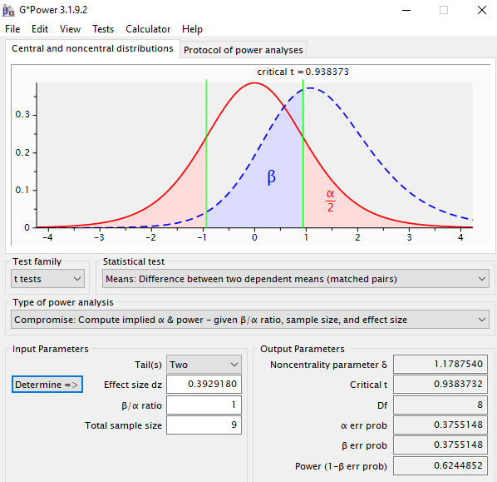

Figure 1.

*Power calculation of the current study using G*Power 3.1.9.2.*

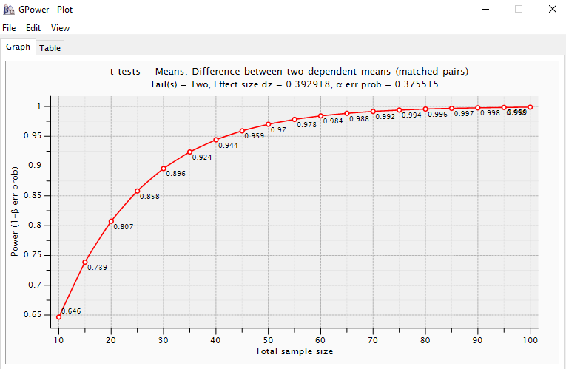

Figure 2.

*Power estimation for the current study using G*Power 3.1.9.2.*

*Appendix 5.*

*Table 1.* Answers to questions posed to participants after the current study.

|  |  |  |
| --- | --- | --- |
|  | ABI group | Non-ABI group. |
| How did you find it? | “I’m glad that I didn’t have to do this straight after my accident’’. (P52)  “I didn’t enjoy it. I closed my eyes during some of it…. When I was in VR”. (P53)  “Hard. I think having three kids has taught me to ignore stuff though, noise and stuff”. (P60)  “It was ok, I didn’t find it hard” (P59) | “It was ok. I didn’t find it too hard”.  “I knew I was making errors but only realised after I had started saying it” |
| Did you find it more difficult in VR? | “Yes, it was horrid, I wanted to escape”. (P52)  “No, I think I did the same” (referring to VR and non-VR). (P59)  “I found it made me a bit panicky.” (P53)  “Of course, I did”. (P55) | “Not really, I suppose it was a little bit harder but not that much”  “Yeah, could that be because I drink too much?” |
| Did you introduce any strategies to aid your performance? | “What do you mean?” (once it was explained to them) “No, I didn’t”. (P73)  “No, should I have?”. (P55)  “No, I don’t think I needed to”. (P59) | “Yeah, I just named things that I could see”  “I just looked around and answered”  “Yes, I found it easier to just say a list of colours that to think of different things”  (said when laughing) “I like cars!” (named a list of cars) |

*Table 2*. Observations made of participants during the administration of the HSCT in the VR environment.

|  |  |  |
| --- | --- | --- |
|  | ABI group | Non-ABI group |
| Physical movement | Movement carried on throughout both tasks. There was no observed difference between trials in the VR condition.  Several participants displayed movement that might be considered anxious; foot twitching, rigidity, breathing got faster. | Limited movement during the inhibitory task compared to the non-inhibitory task. |
| Spoken | Several participants remarked that they did not like the test.  Most participants made non-word sounds that could be interpreted as expressions of either frustration or discomfort; sighing, ‘argh’, ‘grrr’.  Some participants made verbal utterances that demonstrated frustration or discomfort; expletives, ‘no’, ‘opps’ etc. | Several participants remarked that they found the test ‘annoying’.  Most participants made sounds of annoyance when they got an answer wrong.  Three participants gave the inhibitory answers and lists;  Two listed colours, one listed car makes.  7 participants used visual cues from the environment as prompts for answers; fire extinguisher, stairs, chair, clothing of people walking past. One participant used the name of a friend who walked into the visual field. |
| Visual field movement. | All participants followed the movement of individuals as they passed through the environment.  All participants scanned the environment when in VR, often when there was no distractor moving through the visual field. | Participants seldom moved their visual field from a semi fixed position. When they did it often followed with an environmental cue answer |